Bulb Crops
Bulb crops (Crop Group 3) consist of garlic, leeks, dry-bulb, and green onions. These crops are particularly important in the Lower Rio Grande Valley and High Plains. Asterisks indicate representative crops for the Group.
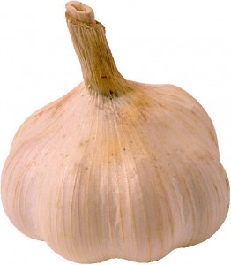Garlic (including leeks and shallot). Garlic is a high-value crop but high labor requirements and market uncertainties limit production. Mostly produced in East Texas from transplants. Texas garlic has a high pungency. In some years it may be grown under contract in Far West Texas for dehydrator processing. Leek is produced on 50 to 100 acres in small tracts for roadside and local grocery sales. Shallot is grown on 20 acres. Pests are similar to those of onion.
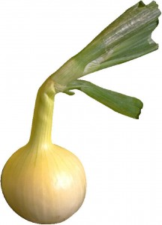Onions – dry bulb*. Onions are the leading vegetable crop with annual cash sales of $60 to $100 million and grown from both direct seed and transplants. Texas ranks fourth in U.S. production. The LRGV and WG produce early short-day, mild-flavored white and yellow granotype onions. Planted October to November for March to June market windows. Crop is hand harvested, field dried, and shipped throughout the U.S. and exported. Texas’ 1015 “super sweet” is the most common. Several large packing sheds in the Valley, High Plains, and Far West Texas handle intermediate day onions for fresh market. East Texas onions are mostly grown for local sales. Onion breeding in Texas focuses on quality, earliness, shipping ability, and host plant resistance. Insect
pests include onion thrips, spider mites, cutworm, wireworm, onion maggot, white grub, flea beetle, beet and fall armyworm. Weeds include broadleaf weeds, pigweed, purslane, nightshade, ragweed, sunflower, wild mustard, nutsedge, bermudagrass, and johnsongrass. Diseases include Botrytis, downy mildew, purple blotch, pink root, and nematodes. See onion crop profile or crop brief for more details.
Onions – green*. Grown in small plots for mixed load shipments with other crops for direct marketing fromLRGV and WG to metro center wholesalers. Harvested by hand when tops are still green. Pests are similar to those of dry bulb onions.
Table 6. Bulb crops (Crop Group 3)
Crop | Statewide Production |  |  | Acreage by Production Region
 | Acres | Dollar Value per Acre | Total Value (dollars in thousands) | Lower Valley | Winter Garden | Plains Region | Far West Texas | Eastern Areas
Garlic and leeks | 500 | $4,200 | $2,100 | 150 | 20 | 20 | 250 | 60
Onion – dry bulb | 16,700 | $5,200 | $86,840 | 10,500 | 2,000 | 600 | 3,000 | 600
Onion – green | 500 | $3,800 | $1,900 | 200 | 30 | 40 | 30 | 200
Total | 17,700 | $5,132 | $90,840 | 10,850 | 2,050 | 660 | 3,280 | 860

Root and Tuber Crops
Root and tuber crops (Crop Groups 1 and 2) consist of root crops, such as beets and carrots, and tuber crops, such as potatoes and sweet potatoes, and the leaves of root crops, such as beet tops. Planted acres and values of these crop types are shown in Table 5. Details of growing areas and pests are given in the specific descriptions for each crop in this section. Representative crops in each Crop Group are designated by an asterisk.
Beets – table. Most production of beets is in the Winter Garden under contract with commercial processors, with guidance from field managers to reduce pest losses. Spring planting starts in February; crops are harvested by May 1. Summer season is from August to November. Lower Rio Grand Valley provides early fresh market shipments; 50% is processed. High Plains produces for fresh market and pigment extraction. Common insect pests include root and foliar aphids, garden web worms, mites, loopers and stink bugs. Weeds include pigweed, sunflower, mustard, and winter annuals. Diseases include Botrytis, leaf spot, powdery mildew, Sclerotinia, curly top, mosaic virus complex, and root knot nematode.
Beet tops. Small acreage grown in LRGV for greens to fresh and processing markets. Pests are similar to those of table beets. Foliage quality and insects are the major concern.
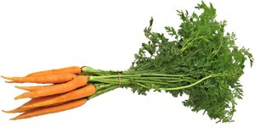Carrots*. Texas is the fifth leading producer with 60% for fresh market and 40% for processing. Carrots are planted July to November with staggered harvest dates from November to May. One-third goes into “cello” (plastic bag) markets. “Baby carrots” are tips cut from jumbos or “cut baby carrots”. Some sequential production in WG and High Plains areas. Soil insect pests include carrot weevil, wireworms, grubs, and nematodes. Foliar pests are armyworms, leafhoppers, aphids, flea beetles, and mites. Weeds include mostly winter annual broadleaves: pigweed (most common), nutsedge (difficult to control), and dodder (entangles carrots and makes harvesting difficult). Diseases include damping off, Alternaria, leaf blight, Cercospora leaf blight, bacterial leaf blight, southern blight, powdery mildew, aster yellows, and root nematodes. See carrot crop profile or crop brief for more details on pesticides.
Parsnips. Grown similar to carrots but with a longer growing season in LRGV and WG areas for local fresh market sales. Diseases include bacterial blight and powdery mildew. Other pests similar to those of radish or turnip. In Europe, parsnip was an important carbohydrate for centuries.
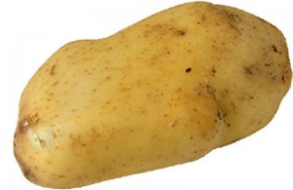Potato-Irish*. Commercially produced April to July for early fresh market in the U.S.; 50% is white Russets for table stock (mostly from High Plains); 20% are red skins for fresh markets; and 20% for processing. East Texas noted for spring “new potatoes” from small acreages in sandy soil for local and roadside sales. High Plains harvest from July through September with adjacent production in eastern New Mexico. Total production varies from 18,000 to 32,000 acres. Texas A&M maintains the only potato breeding program in the South Central U.S. focusing on quality and host plant resistance, while Northern states provide seed stock to Texas for planting. Insect pests include wireworm, flea beetle, aphids, potato psyllid, thrips, leaf hopper, grasshoppers, spider mites, cabbage looper, Colorado potato beetle, and white grubs. Weeds include nutsedge, pigweed, purslane, sunflower, Russian thistle, morningglory, bermudasgrass, johnsongrass, Texas Panicum and field bindweed. Diseases include Botrytis, Fusarium wilt, late and early blight, scab, blackleg, southern blight, root knot nematodes, Verticillium wilt, and virus complex. Fungicide protection is essential some years.
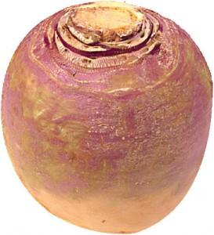Turnips. Grown in East Texas with nearly year-round planting for roadside sales and home use. Insects include aphids, beetles, mites, imported cabbageworm, armyworm, and flea beetle. Diseases include black rot, powdery mildew, and Rhizoctonia root rot. Other pests are similar to those of radishes.
Turnip greens. Grown in multiple plantings from fall to spring; 75% is for fresh market and sold to local groceries, roadside sales, and home use. Pests are similar to those of turnips and radishes, with emphasis on foliage quality.
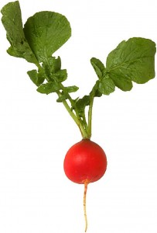Radishes*. Production of red globe types for in-state markets. Most production is in small successive plantings every 10 to 14 days in East Texas. Harvested early to avoid pithiness. One hundred acres of daikon (Oriental radish) is grown for local Asian markets. Insect pests include armyworms, beetles, root pests, and others. Glyphosate may be applied for winter annual weeds before planting for a “stale seedbed”. Diseases include white rust, Cercospora leaf spot, bacterial leaf spot, black root, and root knot nematode.
Sweet potato*. Texas is the country’s fifth largest sweet potato producer. Commercial production is concentrated in Van Zandt County in East Texas. The sweet potato breeding program in Louisiana focuses on resistance to soil-borne insects. Sweet potato weevil is the most serious pest and quarantine programs restrict movement of seed stock. Other insect pests include spotted cucumber beetle, wire grub, wire worm, cutworms, leaf hoppers, loopers, hornworms, flea beetle, and white bugs. Weeds include annual grasses, and broadleaf weeds. Diseases include Rhizopus soft rot, scurf, southern blight, root knot nematode, and internal cork. See sweet potato crop profile for more details on pesticides.
Table 5. Root and tuber crops (Crop Groups 1 and 2)
Crop | Statewide Production |  |  | Acreage by Production Region
 | Acres | Dollar Value per Acre | Total Value (dollars in thousands) | Lower Valley | Winter Garden | Plains Region | Far West Texas | Eastern Areas
Beets-roots | 1,300 | $1,200 | $1,560 | 500 | 500 | 200 | 0 | 100
Beets-tops | 211 | $2,100 | $443 | 200 | 5 | 0 | 0 | 6
Carrot* | 5,750 | $3,400 | $19,550 | 3,600 | 1,400 | 700 | 50 | 0
Parsnip | 70 | $1,800 | $126 | 50 | 0 | 0 | 0 | 20
Potato* | 22,000 | $2,800 | $61,600 | 2,000 | 6,500 | 12,000 | 0 | 1,500
Radish* | 550 | $1,800 | $990 | 100 | 50 | 200 | 0 | 200
Sweet potato* | 3,100 | $3,100 | $9,610 | 0 | 0 | 100 | 0 | 3,000
Turnip-greens | 800 | $1,700 | $1,360 | 200 | 200 | 0 | 0 | 400
Turnip-roots | 600 | $1,700 | $1,020 | 100 | 50 | 200 | 0 | 250
Total | 34,381 | $2,800 | $96,259 | 6,750 | 8,705 | 13,400 | 50 | 5,476

Rhizome
From Wikipedia, the free encyclopedia
This article is about the botanical term. For other uses, see Rhizome (disambiguation).
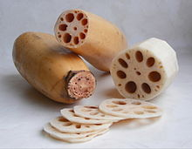
Lotus rhizome
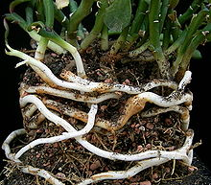
An antique spurge plant; Euphorbia antiquorum, sending out rhizomes
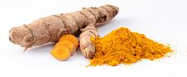
Turmeric rhizome and spice
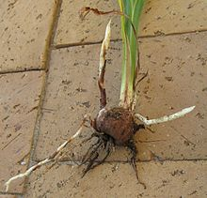
Stolons growing from nodes in cormof Crocosmia.
In botany and dendrology, a rhizome (/ˈraɪzoʊm/, from Ancient Greek: rhízōma "mass of roots",^{[1]} from rhizóō "cause to strike root")^{[2]} is a modified subterranean stem of a plant that is usually found underground, often sending out roots and shoots from its nodes. Rhizomes are also called creeping rootstalks and rootstocks. Rhizomes develop from axillary buds and are diageotropic or grow perpendicular to the force of gravity. The rhizome also retains the ability to allow new shoots to grow upwards.^{[3]}
If a rhizome is separated into pieces, each piece may be able to give rise to a new plant. The plant uses the rhizome to store starches,proteins, and other nutrients. These nutrients become useful for the plant when new shoots must be formed or when the plant dies back for the winter.^{[3]} This is a process known as vegetative reproduction and is used by farmers and gardeners to propagate certain plants. This also allows for lateral spread of grasses like bamboo and bunch grasses. Examples of plants that are propagated this way includehops, asparagus, ginger, irises, Lily of the Valley, cannas, and sympodial orchids. Some rhizomes which are used directly in cooking include ginger, turmeric, galangal, and fingerroot.
Stored rhizomes are subject to bacterial and fungal infections, making them unsuitable for replanting and greatly diminishing stocks. However, rhizomes can also be produced artificially from tissue cultures. The ability to easily grow rhizomes from tissue cultures leads to better stocks for replanting and greater yields.^{[4]} The plant hormones ethylene and jasmonic acid have been found to help induce and regulate the growth of rhizomes, specifically in rhubarb. Ethylene that was applied externally was found to affect internal ethylene levels, allowing for easy manipulations of ethylene concentrations.^{[5]} Knowledge of how to use these hormones to induce rhizome growth could help farmers and biologists producing plants grown from rhizomes more easily cultivate and grow better plants.
The poplars (species of Populus) are an example of trees that propagate using a rhizome. The Pando colony in Utah is a famous example, which has been living for about 80,000 years. The rhizome of a poplar colony is the key to its longevity: foragers, insects, fungus, and forest fires may destroy the above-ground portion of the tree, but the underground rhizome is somewhat protected against these threats.
A stolon is similar to a rhizome, but, unlike a rhizome, which is the main stem of the plant, a stolon sprouts from an existing stem, has long internodes, and generates new shoots at the end, such as in the strawberry plant. In general, rhizomes have short internodes; they send out roots from the bottom of the nodes and new upward-growing shoots from the top of the nodes. A stem tuber is a thickened part of a rhizome or stolon that has been enlarged for use as a storage organ.^{[6]} In general, a tuber is high in starch, for example, the commonpotato, which is a modified stolon. The term tuber is often used imprecisely, and is sometimes applied to plants with rhizomes.
Some plants have rhizomes that grow above ground or that lie at the soil surface, including some Iris species, and ferns, whose spreading stems are rhizomes. Plants with underground rhizomes include gingers, bamboo, the Venus Flytrap, Chinese lantern, Western poison-oak,^{[7]} hops, and Alstroemeria, and the weeds Johnson grass, bermuda grass, and purple nut sedge. Rhizomes generally form a single layer, but in Giant Horsetails, can be multi-tiered.^{[8]}
Many rhizomes have culinary value, and some, such as zhe'ergen, are commonly consumed raw.^{[9]}

